**Lab: 03**

**Object: To learn RMI basics: Generate the stubs and skeletons and run client and server.**

**Task1: Create RMI program in which server performs basic arithmetic operations.**

**1)Interface on both client and server side.**

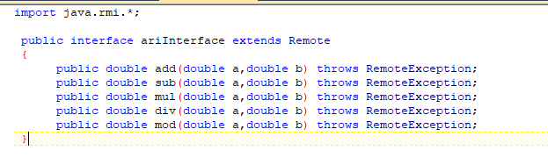

**2)Server Remote object class:**

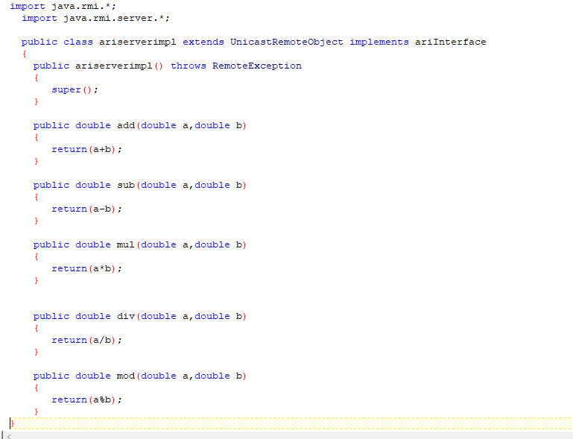

**3)Server main class:**

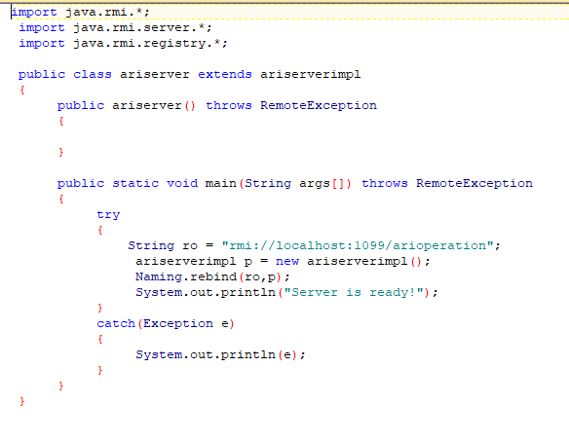

**4)Client main class:**

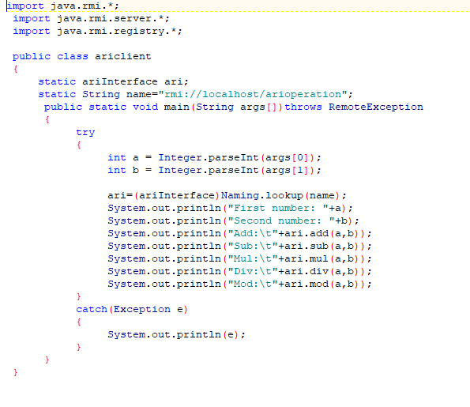

**Output:**

**First compile all the classes.**

**Then create skeleton of server remote object class:**

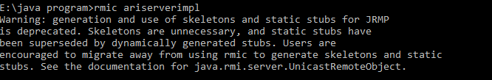

**Then start registry to register server remote object.**



**Then run server main class:**



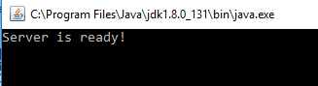

**And finally run client main class:**

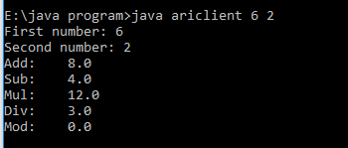

**Task2:** **Create RMI program in which server sorts the numbers in ascending order.**

**1)Interface on both client and server side.**

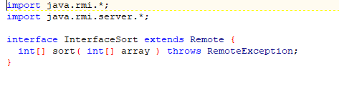

**2)Server Remote object class:**

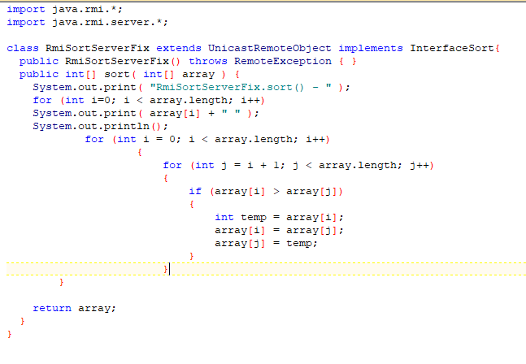

**3)Server main class:**

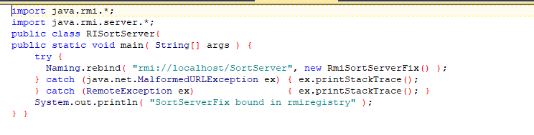

**4)Client main class:**

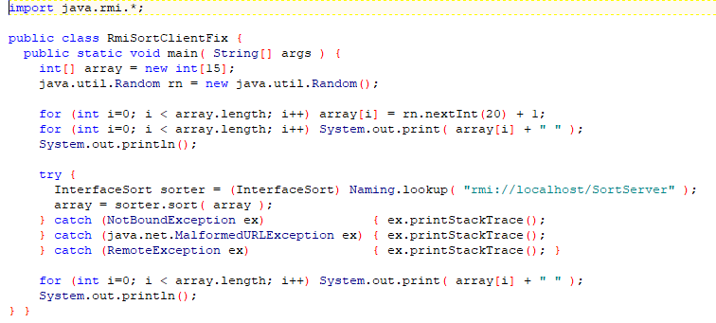

**Output:**

**First compile all the classes.**

**Then create skeleton of server remote object class:**

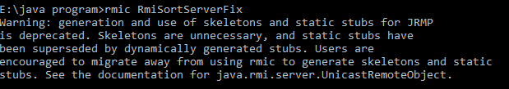

**Then start registry to register server remote object.**



**Then run server main class:**



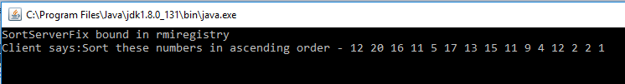

**And finally run client main class:**



**(Optional Task)**

**Task3:Write an RMI program to implement the Map/Reduce concept of Hadoop on the server program. In other words the client program asks user to provide multiple sentences and send to server, server sends back the word counts.**

**1)Interface on both client and server side.**

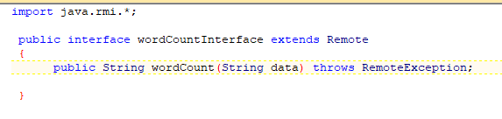

**2)Server Remote object class:**

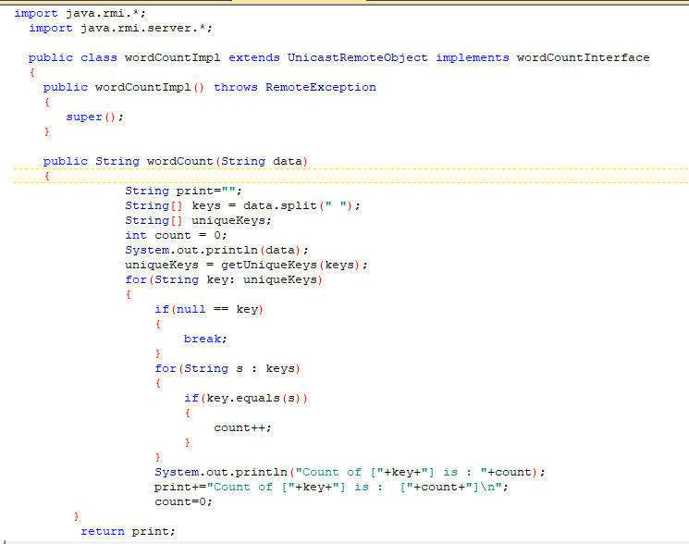

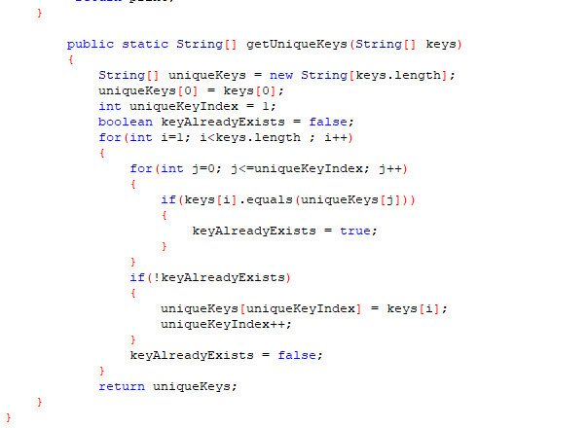

**3)Server main class:**

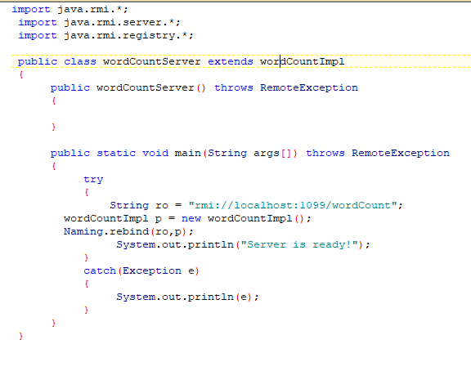

**4)Client main class:**

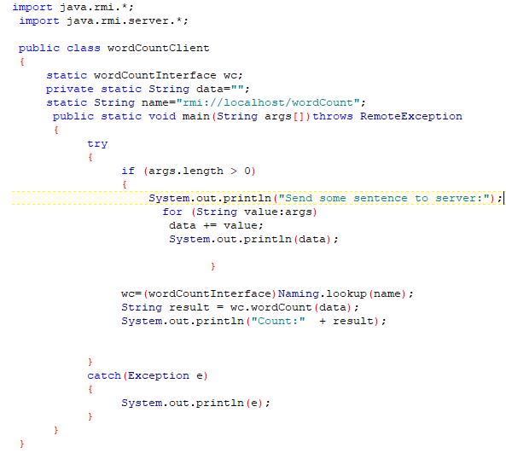

**Output:**

**First compile all the classes.**

**Then create skeleton of server remote object class:**

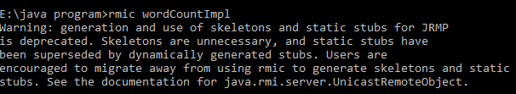

**Then start registry to register server remote object.**



**Then run server main class:**





**And finally run client main class:**

